CC3 Unity Tools

Contents

Overview

This package allows the import and automatic setup of materials in Unity 2020.3 LTS and above, of Reallusion's 'Character Creator 3' and 'iClone' character exports.
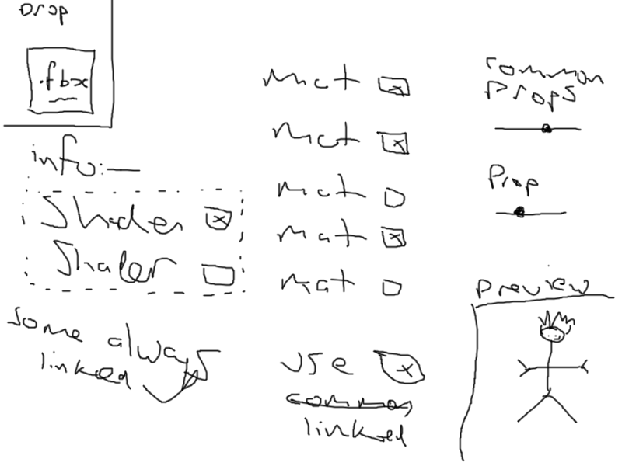
The material and shader setup closely mirrors the visual quality of CC3/iClone using either the HDRP or URP render pipelines in Unity.

With HDRP the import can be processed to utilise a very high quality shadergraph, or a simpler higher performance shader with minimal loss of visual quality.

With URP ...something else



Usage:

Drag your exported character; i.e. the <name>.fbx, & <name>.json files, along with the <name>.fbm and textures directories (should they have been exported according to your settings)

